SQLite 22

Database and programming



LILLEBAELT ACADEMY OF
PROFESSIONAL HIGHER EDUCATION

Author
Martin Grønholdt
mart80c7@edu.eal.dk

Sunday 21 May 2017

Table of Contents
1. Introduction 1
2. Database structure 2
3. The view 3

Introduction
This hand in is about using views in SQLite databases, it reuses the database created in the las hand in.

All hand ins for this course are available on GitHub at:
https://github.com/deadbok/eal_programming

Database structure
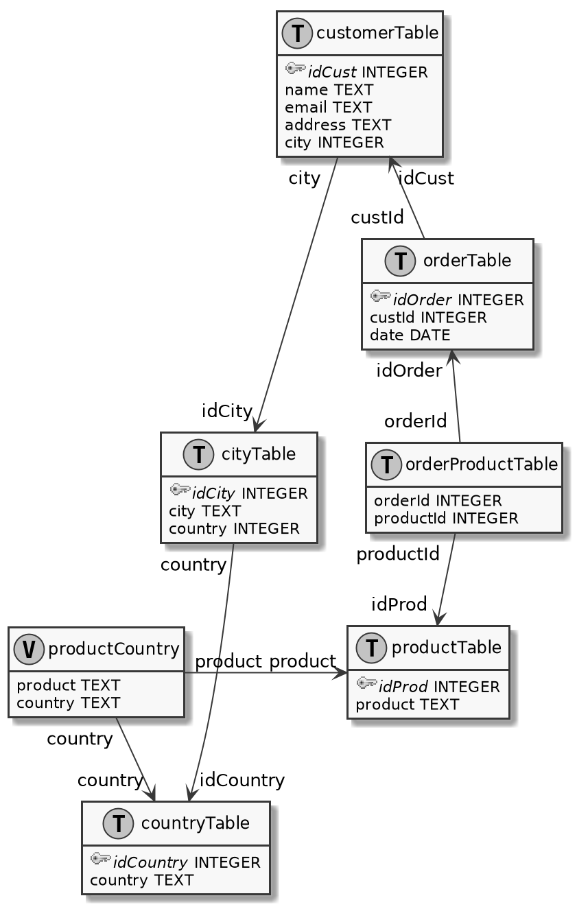
Database diagram with the view denoted "V"
The diagram has only changed in that a view has been added.

The view
A SQL VIEW behaves like a macro, you assign a name to a SELECT statement. You can then use the view in place of a table in a SELECT query. In the above diagram the view includes the fields “product” from the “productTable”, and “country” from the “countryTable”, giving the following result:
sqlite> SELECT * FROM productCountryView;
product|country
Anto Virus|England
HDMI cable|Denmark
Mouse|England
CPU|Lithaunia
HDMI cable|England
Anto Virus|Lithaunia
Using the view to show all data.
The SELECT statement that this view is based on uses a lot of references to get from the fields in orderProductTable to the fields in productTable and, countryTable.
SELECT productTable.product, countryTable.country
FROM productTable, orderProductTable, orderTable,customerTable, cityTable, countryTable
WHERE productTable.idProd=orderProductTable.productId
AND orderProductTable.orderId=orderTable.idOrder
AND orderTable.custId=customerTable.idCust
AND customerTable.city=cityTable.idCity
AND cityTable.country=countryTable.idCountry;
The SELECT statement used in productCountryView.
To turn this SELECT statement into a view add “CREATE VIEW view_name AS select_statement”.
CREATE VIEW productCountryView AS
SELECT productTable.product, countryTable.country
FROM productTable, orderProductTable, orderTable,customerTable, cityTable, countryTable
WHERE productTable.idProd=orderProductTable.productId
AND orderProductTable.orderId=orderTable.idOrder
AND orderTable.custId=customerTable.idCust
AND customerTable.city=cityTable.idCity
AND cityTable.country=countryTable.idCountry;
The SQL statement to create the productCountryView.

